**CHAPTER – I**

**INTRODUCTION**

**1.1 INTRODUCTION**

The pump, at its recommended rotational speed, should have sufficient capacity to ensure that the sprayer operates efficiently when fitted with the largest recommended size of nozzles operating at the maximum rated pressure plus an additional 20% to account for nozzle tolerances and to provide tank agitation.

It should be possible to remove the pump from the sprayer without draining the tank(s).

The pump should be permanently marked with:

* Maximum flow rate and operating pressure
* Recommended and maximum rotational speed
* Name and address of manufacturer
* Model/type and year of manufacture

Today, India ranks second worldwide in farm output. Agriculture and allied sectors like forestry and fisheries, accounted for 13.7% of GDP (Gross domestics product) in 2013 about 50% of the total workforce. The economic contribution of agriculture to India’s GDP is steadily declining with the country broad based economic.

India is agriculture country. In India there are many equipment’s formed for farming. In the farm there are many types of lands available and whether conditions also different. In India there are different types of fruits, vegetables and grains produced and that sold in market.

|  |  |  |  |
| --- | --- | --- | --- |
| **S. No.** | **Name of crop** | **Distance between plant** | **Height of crop** |
| 1 | Sorghum | 0.70 feet | 5.5-7 feet |
| 2 | Sugarcane | 1 feet | 5.5-7 feet |
| 3 | Corn | 0.35 feet | 3-4 feet |
| 4 | Pearl millet | 0.75 feet | 5.5-7 feet |
| 5 | Soybean | 0.5 feet | 1 - 2 feet |
| 6 | Cotton | 2 - 2.5 feet | 4 - 6 feet |

**Table 1.1:** Distances (horizontal & Vertical) and height of crop

In India around 70% of the population earns its livelihood from agriculture. It still provides livelihood to the people in our country. It full fills the basic need of human being and animals. It is an important source of raw material for many agro based industries. India’s geographical condition is unique for agriculture because it provides many favourable conditions. There are plain areas, fertile soil, long growing season and wide variation in climatic condition etc.

Spraying of agrochemicals in the field is a tedious and laborious task. The conventional knapsack sprayer available in the market requires manual labour to operator, which is difficult to find due to movement of farm labourers towards cities. The small formers cannot afford to buy the power operated sprayer or tractor mounted sprayers available in the markets, as these are very costly and are of not much use to small formers due to small land holdings.

Agriculture sprayer pesticide machine is designed to reduce human effort. It used to agriculture field by spray pesticide in farm to get better crop. Agriculture spray adjacent is used with pesticides order to enhance such as herbicides, insecticide, fungicides and other agents that control for eliminate.

It used to agricultural spray pesticide. Now a days farmers more used pesticide in farm to get better crop. Agricultural spray adjacent is used with pesticides order to enhance such as herbicides, insecticide, fungicides and other agents that control or eliminates unwanted pests.

Sprayers are commonly used on farms to spray pesticides, herbicides, fungicides, and defoliants as a means of crop quality control. There are many kinds of machine-operated sprayers, the most common of which are low-pressure, high-pressure, air-carrier and fogger types.

Insects and weeds are largely responsible for the crop destruction. In modern horticulture and agriculture, insecticides/pesticides, a man made or natural preparation are used to kill insects or otherwise control their reproduction. These herbicides, pesticides, and fertilizers are applied to agricultural crops with the help of a special device known as a "Sprayer."

 Based on the concept of high or low pressure, sprayer provides optimum performance with minimum efforts. There are several types of sprayers available in the market such as manual or self-propelled sprayers, tractor mounted sprayers and aerial sprayers.

 Science and technology always help the mankind to improve its life. This thing applies to the agriculture sector too. Innovative human brains use their creative power and blend it with the principles of mathematics and physics to develop an ultimate range of plant protection equipment’s, showcasing the highest degree of human excellence. The invention of a sprayer, pesticides, fertilizers, etc. brings revolution in the agriculture/horticulture sector.

Especially the invention of sprayers, enable farmers to obtain maximum agricultural output. They are used for garden spraying, weed/pest control, liquid fertilizing and plant leaf polishing. It is available in man-portable units, self-propelled units.

**1.2 HISTORICAL BACKGROUND**

**1.2.1 Hand-pulled sprayers**

Hand-pulled herbicide sprayers are like a knapsack sprayer mounted on wheels. When the wheels turn, they pump the herbicide into a boom with four or six Spray nozzles. The height of the boom can be adjusted to deal with plants of different heights. These sprayers are sometimes called “pedestrian-pulled” sprayers. They have more nozzles and a larger tank than a knapsack sprayer, so can cover a lager areas more evenly. They are Suitable for treating a whole field; they cannot be used to spot-spray in- dividable patches of weeds. Because the spray is behind the operator (unlike with knapsack sprayers), there is much less risk of breathing in the spray of getting it on your skin other clothing.

**1.2.2 Animal-pulled sprayers**

Animal-powered sprayers many have up to 10 nozzles (spaced about 50cm apart). They can be pulled by one or two animals. They have a large capacity than hand sprayers, so are suitable for larger areas.

**1.2.3 Tractor-powered sprayers**

Tractor-powered sprayers can be very sophisticated. They are suited for large farms. It may be possible to hire someone to spray your farm with a tractor sprayer, rather than investing in one yourself.

**1.2.4 Bicycle sprayer**

Aware of the problem faced in the spraying of agrochemicals in the field, decided to develop a sprayer which is efficient and affordable by the farmers. He decided to mount the sprayer on a bicycle, which can be found in every household.

This portable spraying system consists of an adjustable boom, tank, and chain and sprockets and cam follower mechanism for converting rotary motion to reciprocating motion. The assembly can be mounted on any bicycle available in the market. A cylindrical tank containing the solution is firmly attached to the frame of the bicycle.

While the bicycle is pulled forward, the cam follower provides reciprocating motion to pump, which compresses the fluid in the tank. This comes out through the spraying nozzle, connected to boom, as mist. This sprayer is energy-efficient and easy to operate and maintain. As it is a flexible product with adjustable height and width of spraying boom there is greater flexibility for using it for various crops.

Since the bicycle requires less space to move, it can be used in a more versatile manner as compared to power sprayers that are mounted on tractors. A labour saving device, it can be used to spray one acre of land in 45 minutes thus covering more area compared to manual spraying. Easy to assemble and dissemble, it server the dual use of sprayer cum bicycle.

**1.3 HAND-OPERATED SPRAYERS**

There are various types of hand-operated sprayers, but they can be broadly categorized into two groups:

Sprayers with hydraulic nozzles designed with systems to generate pressure at the Nozzle to achieve correct atomization. With lever-operated sprayers the main tank is not pressurized, but spray pressure is generated in a Pressure chamber by constant pumping. With compression sprayers, the whole tank is pressurized prior to spraying.

**1.3.1 Mechanism Lever-Operated Knapsack Sprayer**

Rotary atomizers, which generate spray droplets from a spinning disc or cup. These types typically apply low volumes of spray liquid per hectare. These Low volumes mean that higher concentrations of spray liquid are applied; this makes them unsuitable for some products.

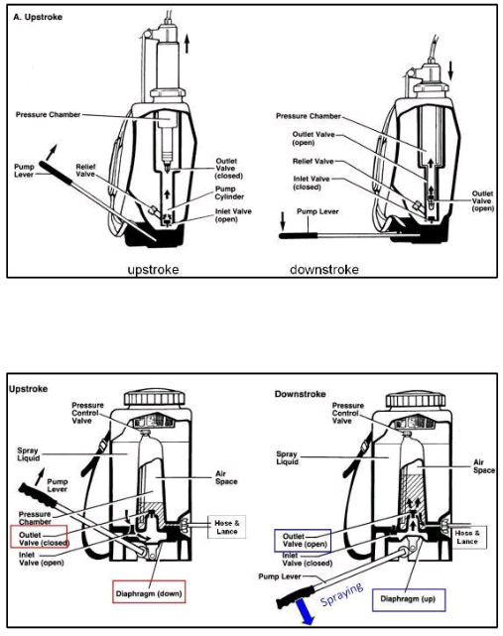

**Fig 1.1:** Lever operated knapsack sprayer

In particular they should never be used for parquet application as the concentrations are likely to exceed recommended dilution rates.

1. Sprayer with centrifugal-energy nozzles

2. Electrostatic spraying equipment

3. Rope-wick herbicide applicators

**1.4 SUPPLEMENTARY POINTS**

Hand-operated, hydraulic sprayers or hand-held spinning disk sprayers are commonly use in Asian countries in applying pesticides. Sprayers with centrifugal-energy nozzles are also termed "controlled droplet application (CDA) sprayers” Rope-wick herbicide applicators were developed specifically to apply low volumes of highly concentrated herbicides, to weeds that grow taller than crops. The herbicide solution is rubbed on any weeds that come into contact with the rope wick.

**1.5 LEVER-OPERATED KNAPSACK SPRAYERS**

Diaphragm pumps - are suitable for durable option where applications are made through a single nozzle. They are also suitable for multi-nozzle booms where relatively low spraying pressures are adequate (1 bar). Piston pumps - are suitable for single nozzle use and are preferred to diaphragm pumps for multi-nozzle use where higher pressures are required (to 4 bars). 13 Push Operated Spray Pump. Under arm levers are preferred to over-arm levers except where crop conditions impede the movement of the lever.

**1.5.1 Motorized hydraulic knapsack sprayers**

These units can make good sense in high value crops for use with multi-nozzle booms where prolonged pumping, even with a piston machine, is not practical.

**1.5.2 Compression Sprayers**

Compression sprayers are necessary where field conditions make lever-operated machines impractical, for example on steep slopes and in dense crop foliage. They are also used in grain stores to treat wall surfaces.

**NOTE -:** The output from this type of sprayer declines during the pressure cycle unless a flow control valve is fitted to the sprayer.

**1.5.3 Motorized Mist blowers**

Motorized mist blowers are used where the spray cloud needs to be projected vertically to treat trees, but may be used to spray horizontally for multi-row and bush crop spraying. They can also be adapted for granule application. They are not recommended for herbicide application.

**1.6 NOZZLE CHOICE**

The provision of the correct nozzle for the job enables safer and more efficient spraying. Appropriate nozzles for the intended task should be supplied with the equipment. A minimum of one nozzle type suitable for herbicide application and one for fungicide/insecticide application shall be supplied with the equipment. Deflector nozzle (also called impact, flood or anvil nozzles) is used for single nozzle application of soil applied herbicides. Flat fans are best for spraying products onto flat surfaces: for foliar applications, the application of herbicides to soil and insecticides onto walls for control of stored product pests. Hollow cone nozzles are used for general spraying of foliage and give good coverage of the outer parts of a canopy (used to apply insecticides and fungicides).

Solid cone nozzles are used for spot and band spraying. Adjustable multipurpose nozzles are not recommended for crop protection use. Spray quality is difficult to reproduce and this type of nozzle encourages operators to adjust and touch nozzles contaminated with pesticide.

**1.7 KNAPSACK SPRAYERS**

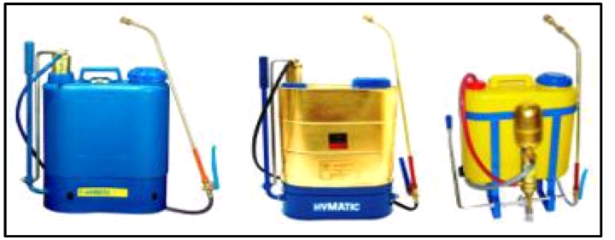

**Fig1.2:** Knapsack sprayers

* Any sprayer which is carried on the back of the operator is called a knapsack sprayer.
* The commonly used manually operated knapsack sprayer will have one hydraulic pump working inside the container.
* The plunger works inside the replacement well attached at the bottom of the container, for easier maintenance.
* The pump can be operated through the appropriate linkages by oscillating the handle, with the sprayer carried on the back.
* An agitator is also provided with the pressure chamber to agitate the fluid so that the particles in suspension will not be allowed to settle down.
* A delivery tube is attached on the other end of the pump which carries the pressurized fluid to the spray lance.
* The knapsack sprayer develops 30 - 40 psi pressure.

1. Compression Free hand Compact Pressure drop.

2. Piston Constant pressure big pressure range easy service easy cleaning higher wear rate.

3. Diaphragm Constant pressure Wear resistant more volume / stroke Small pressure range more parts.

**CHAPTER – II**

**LITERATURE SURVEY**

Sprayers are commonly used on farms to spray pesticides, herbicides, fungicides, and defoliants as a means of crop quality control. There are many kinds of machine-operated sprayers, the most common of which are low-pressure, high-pressure, air-carrier, and fogger types. Though methods of chemical pest control have been used for centuries, they were not always spread by machine; before the 1800s, most pesticides were applied by hand.

Sudduth K.A., Borgelt S.C., Hou J., (1995)Performance of a chemical injection sprayer system, Performance of a chemical injection sprayer system, found the time delay of concentrated pesticides through injection sprayers to be significant, and proposed injection at the individual nozzles as a possible solution to shorten delays. Development of a direct nozzle injection system that overcame the concentration variation problems reported  by previous  researchers. Simulations are used to compare chemical application accuracies for various designs ofinjection sprayers. They found that reducing the diameter of the fluid lines near the end of the spray booms improved overall application accuracy.

Way T.R., Von Bargen K., Grisso R.D., Bashford L.L., (1992)Simulation of chemical application accuracy for injection sprayers. An autonomous mobile robot for use in pest control and disease prevention applications in commercial greenhouses. They develop the robot platforms ability to successfully navigate itself down rows of a greenhouse, while the pesticide spraying system efficiently covers the plants evenly with spray in the set dosages. The main application of robots in the commercial sector has been concerned with the substitution of manual human labour by robots or mechanized systems to make the work more time efficient, accurate, uniform and less costly.

Philip J. Sammons, Tomonari Furukawa, Andrew Bulgin, (2005)Autonomous Pesticide Spraying Robot for use in a Green house, The University of Nairobi develop the system like centrifugal pump is the most common non-positive displacement pump. The output from this type of pump is influenced by pressure. This pump is ideal for delivering large volumes of liquid at low pressures. A key component of the centrifugal pump is the throttling valve. A manual throttling valve on the main output line is essential for the accurate operation of the centrifugal pump. The use of herbicides has replaced much of the mechanical tillage done formerly. Chemical application is done with attachments to tillage machines and seeders or with single-purpose chemical application.

* Early sprayers were most likely first developed to apply fungicides to the vineyards of Bordeaux, France. Between 1850 and 1860, John Bean of California, D.B. Smith of New York, and the Brandt Brothers of Minnesota, developed the hand-operated insecticide sprayer.  
  1874 marked the year that knapsack sprayers first entered the U.S. market.
* At the beginning of the following decade, the first commercial spraying machine was introduced. By 1887.
* In 1894, the first steam-powered sprayer was produced Advancements continued, and by beginning of the 20th century, the first gasoline engine powered sprayer was on the market.
* 1911 saw, the introduction of a pressure regulator and air chamber; these were employed to achieve smooth, uninterrupted spraying.
* In 1914, Moses Rittenhouse began producing 'orchard sprayers' for the fruit-producing region in Niagara, later founding M.K. Rittenhouse.
* Several years after the development of the row-crop tractor in 1925, tractor mounted sprayers were introduced.
* The same year, low-volume, low-pressure sprayers were introduced. In 1945. At that time 10,000 power sprayers were produce. In 1950, 75,000 power sprayers were produced.
* Since 1995 FAO-AGSE has worked on the formulation of guidelines to improve the safety and efficiency of the most commonly used types of spray equipment.
* The first versions of the FAO(Food and Agricultural Organization) guidelines on pesticide application equipment were approved for publication in May 1997 by; the FAO Panel of Experts on Pesticide Specifications, Registration Requirements, Application Standards and Prior Informed Consent; and the FAO Panel of Experts on Agricultural Engineering.

**CHAPTER-III**

**RESEARCH METHODOLOGY**

**3.1 PROBLEM DEFINATION**

Now a day’s traditional spraying pumps we observing following problems:

Costly for farmers having small farming lands, the spraying is traditional done by labour carrying backpack type sprayer which require more human effort, traditional spraying method having more time consuming, efficiency of traditional spraying method is less, and in traditional spraying methods require pressure is not produce.

As Above problems we sort out by our project. We decrease the human effort by using cycle sprayer, the area of spraying acquire large area than traditional sprayer. The efficiency of our sprayer is larger and continuous; it covers two rows at a time. Cycle Sprayer sprays pesticide constantly all over spread on vegetables and crops. This sprayer is reasonable for small area farm. Moving cycle sprayer not only reduces human effort, but also human stress. This bicycle sprayer faster and reasonable cost.

**3.2 APPLICATION METHOD AND CHOICE OF EQUIPMENT**

Insecticides and fungicides are usually applied as foliar sprays, and herbicides are mostly sprayed either onto the foliage or the soil. Thus spraying of liquid and wet table powder formulations is the most common method of application and consequently a wide variety of hand-operated and power-driven spray apparatus has been developed over the years. Other formulations such as granules, dusts and fumigants require different equipment for their application or none at all. For example, granules can either be applied by mechanical spreaders or broadcast by hand. In Asian countries, most pesticides are applied with small, hand operated, hydraulic sprayers or hand-held spinning disc sprayers. Depending on the type of agricultural practices and economic development of the area, mist-blowers and power-operated hydraulic or rotary cage sprayers mounted on tractor or aircraft may also be used extensively.

**3.3 OBJECTIVE**

* To decrease the operational cost by using new mechanics **:**

In the market there are many types of sprayers are available. And costly, there are many operation methods are used to spray the pesticide.

* To work reliably under different working conditions **:**

We can give the reliability of the Sprayer mechanism and there are no human interference in mechanism, so we can reduce man effort.

* To decrease the cost of the machine **:**

Many Sprayer mechanisms available in the market there are many costly mechanism are used and we decrease the cost and increase the production of Vegetables, crops and fruits.

* To decrease labour cost by advancing the spaying method.
* Machine can operated in small farming land.
* Making such a machine which can be able can be performed for spraying easily.

Need of Farmers

Survey of Agricultural Exhibition

To Select the Project theme

Discussion about Mechanism

Discussion about the part list

To find cost of the project

Design of Project theme

Manufacturing of the part

Assemble of all the part’s

Check the working of Model

**Fig 3.1:** General Procedure in design of multi sprayer

**CHAPTER-IV**

**COMPONENTS OF MULTI SPRAYER PUMP**

The main components of agricultural reciprocating multi sprayer are as follows

**4.1 SPROCKETS**

The name 'sprocket' applies generally to any wheel upon which radial projections engage a chain passing over it. It is distinguished from a gear in that sprockets are never meshed together directly, and differs from a pulley in that sprockets have teeth and pulleys are smooth. We use freewheel and chain wheel for chain and sprocket arrangement.

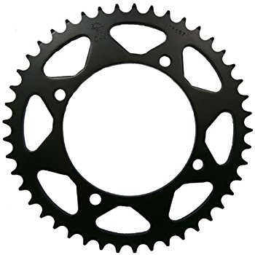

**Fig4.1:** Sprockets

Number of teeth sprocket preferably should have no less than 12 teeth, particularly if speeds are high and the chain loads great. Sprockets having less than 12 teeth should be adopted only to slow and medium speeds. The number of teeth and sprocket speed (revolution per minute) control the amount of impact of the chain seating on the sprocket. Impact is reduced as the number of teeth is increased or as speed is decreased. Likewise the chain pull is reduced as the sprocket size is increased for any one power drive.

Consequently, a lighter chain angular motion or friction in the chain joints is reduced. Height of teeth of standard sprockets is generally based on providing a working face what will accept the maximum possible amount of wear elongation combined with a smooth topping curve. A further limitation that takes precedence over the above is that when a sprocket series is capable of being used with chains designed for conveyor elevator service, the top of the tooth of all standard sprockets having ten or more teeth is designed to be low enough to clear a slat or carrier mounted on the lowest possible “K” attachment of any chain using sprocket of that series. As a precaution, it is recommended that order for sprockets specify whether it is necessary for the top of the tooth to clear any slat, bucket or carrier mounted to a chain attachment, or welded to the chain. Bore and hub sizes are determined by the torque to be transmitted.

The hub specification charts included in this catalog provide selections based on a design shear stress of 6000 psi, maximum. Gapped sprocket some attachments require gapped sprockets to avoid interference between the sprockets and chain or assembled fittings. Such attachments usually are those wherein the space between side bars is utilized by the attachment or its fitting. The gap spacing must be a multiple of the particular attachments spacing in the chain, also of the number of teeth of the sprocket.

Such a limited window of opportunity that you can’t afford to lose extra days getting your spray equipment into shape. Proper maintenance and storage techniques not only streamline next year’s preseason preparations, but also enhance sprayer performance while adding years to its productive life. Long term exposure to many pesticides that pass through a sprayer can corroded and deteriorate sprayer parts, paints and electrical connections. The residue from these products may be harmful to anyone working on or around the machine.

**4.2 CHAIN**

The chain is made of steel which is used to transmit power from gear sprocket to pinion sprocket, and it has a no sleek

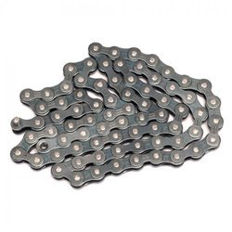

**Fig 4.2:** Chain

**4.3 CRANK**

The function of crank is to transfer motion from prime mover to the connecting rod for further operation. Here the circular disc having eccentricity at which rotary motion of crank is converted into reciprocating/linear motion of connecting rod.

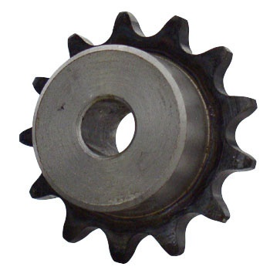

**Fig 4.3:** Crank

**4.4 CONNECTING ROD**

The main function of connecting rod is to convert rotary motion into reciprocating/linear motion. Here connecting rod converts rotary motion of crank to reciprocating motion of pump and extension rod.

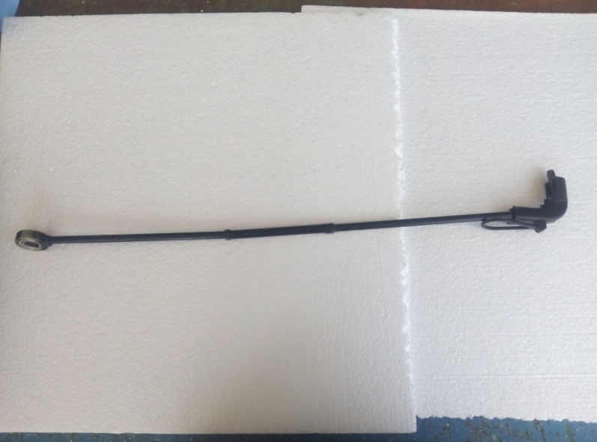

**Fig 4.4:** Connecting rod

**4.5 PUMP**

It consists of piston and cylinder arrangement, it has a lever to operate the motion of piston in reciprocating direction. The pump generates the pressure of 2 bars and discharge of 21 m3/s

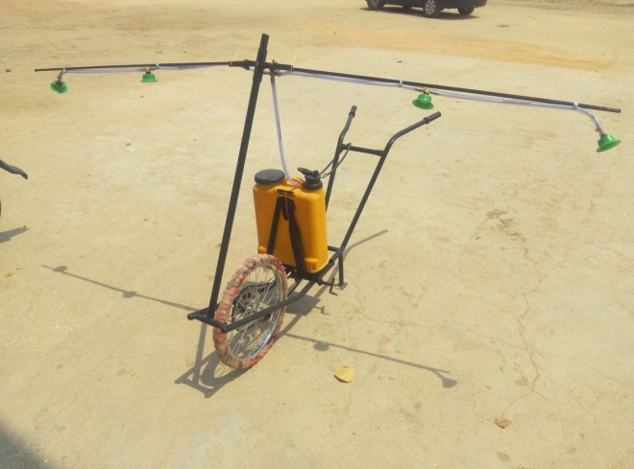

**Fig 4.5:** Pump

**4.6 NOZZLE**

It is a device which converts the pressure energy of fluid into kinetic energy; spray nozzle is a precision device that facilitates dispersion of liquid into a spray. Nozzle is used for purpose to distribute a liquid over an area.

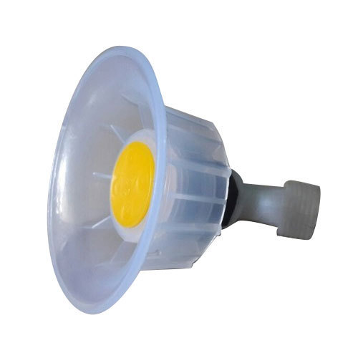

**Fig 4.6:** Nozzle

**4.6.1 WORKING OF NOZZLE**

Nozzle is made from several types of materials. The most common are brass, plastic, nylon, stainless steel, hardened stainless steel, and ceramic. Brass nozzles are the least expensive but are soft and wear rapidly, Nylon nozzles resist corrosion, but some chemicals cause thermoplastic to swell.

Nozzles made from harder metals usually cost more but will usually wear longer. Nozzles wear with use and flow rate. It is important to check and replace worn nozzle regularly, because worn nozzles may increase pesticide application cost and cause crop injury, illegal rates or residue.

For example, a 10 percent increase in flow rate may not be readily notice- able; however, spraying 150 acres with a pesticide that costs $10 per acre at the increased rate would cost an extra $1 per acre or $150 more for the field. Each nozzle on a sprayer should apply the same amount of pesticide. If on nozzle applies more or less than adjoining nozzles, streaking may occur.

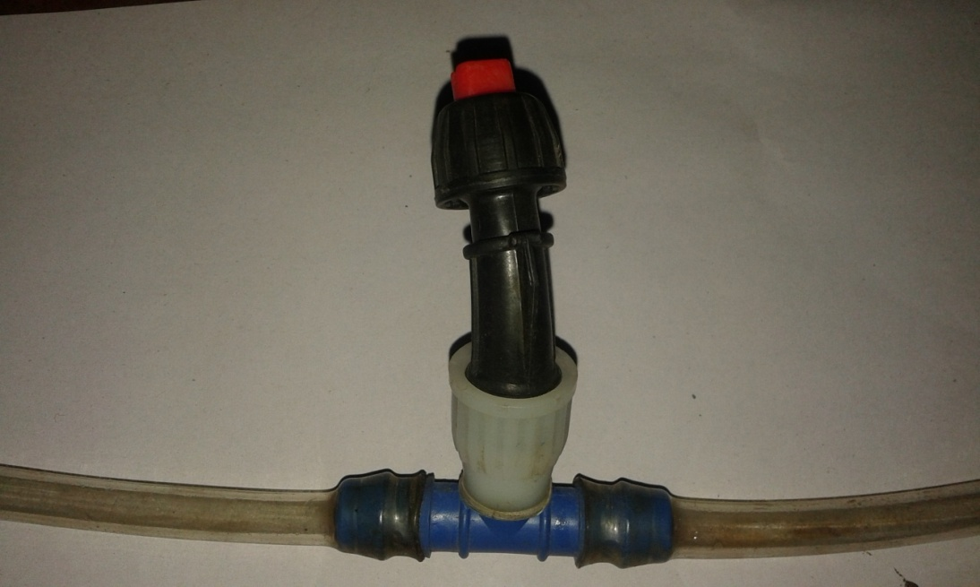

**Fig 4.7:** Working of Nozzle

Nozzle flow rates need to be monitored by regularly collecting the flow from each nozzle under operating conditions and compare the output. If the discharge from a nozzle varies more than 10 %above or below the average of all the nozzles, replace it.

Do not mix nozzles of different materials, types, discharge angles, or gallon capacity on the same sprayer. Any mixing of nozzles will produce uneven spray patterns. Care must be used when cleaning clogged spray nozzles.

The nozzle should be removed from the nozzle body and cleaned with a soft bristled nozzle cleaning brush. Blowing the dirt out with compressed air is also an excellent method. Do not use a small wire or jackknife tip to clean the nozzle orifice as it is easily damaged.

Functions the nozzle is a critical part of any sprayer. Nozzles perform three functions:

1. Regulate flow

2. Atomize the mixture into droplets

3. Disperse the spray in a desirable for others.

In general, herbicides are most effective when applied as droplets of approximately 250 microns; fungicides are most effective at 100 to 150 microns, and insecticides at about 100 microns.

Drift can be minimized by selecting nozzles that produce the largest droplet size while providing adequate coverage the intended application rate and pressure.

**4.6.2 Nozzle Spray Pattern**

1.48 ft 1.48 ft 1.48 ft

430mm430 mm 430 mm

1290 mm

**Fig 4.8:** Nozzle spray pattern

Nozzle Spray Patterns Every spray pattern has two basic characteristics: the spray angle and the shape of the pattern. Most agricultural nozzles have an angle from 65 to 120 degrees. Narrow angles produce a more penetrating spray; wide-angle nozzles can be mounted closer to the target, spaced farther apart on the boom, or provide overlapping coverage. Though there are a multitude of spray nozzles, there are only three basic spray patterns: the flat fan, the hollow cone and the full cone. Each of these has specific characteristics and applications.

Flow Rate Nozzle flow rate is a function of the orifice size and pressure. Manufacturers’ catalogues list nozzle flow rates at various pressures and dies charge rates per acre at various ground speeds. In general, as pressure goes up flow rate increases, but not in a one-to-one ratio. To double the flow rate, you must increase the pressure four times. Many spray control systems use this principle to control output. They increase pressure to maintain correct application rate with an increase in speed. Use caution in speed changes as the spray system pressures may need to operate above recommended nozzle operating ranges, producing excessive drift able fines.

Drop size once the spray material leaves the nozzle orifice; only droplet size, number and the velocity of drops can be measured. Droplet size is measured in microns. A micron is one millionth of a meter, or 1 inch contains 25,400 microns. To give this some perspective, consider that a human hair is approximately 56 microns in diameter.

Flat-Fan Spray Nozzles are widely used for broad-cast spraying of herbicides and some insecticides. They produce a tapered-edge, flat-fan spray pattern. Less material is applied along the edges of the spray pattern, so the patterns of adjoining nozzles must be overlapped to give uniform coverage over the length of the boom. For maximum uniformity, overlap should be about 30% to 50% of the nozzle spacing at the target level. Normal operating pressure is variable depending on the nozzle used. Lower pressures produce larger droplets, which reduce drift potential, while higher pressures produce small drops for minimum plant coverage, but small drops are more susceptible to drift.

Newer extended range nozzles are available that will operate over a range of 15 to 60 psi without causing a significant effect on the width of the spray pattern. These nozzles produce the same flow rate and spray pattern as a regular flat-fan nozzle at the same pressure. Lower operating pressure produces larger droplets and reduces the drift potential while the higher pressures produce larger droplets and reduces the drift potential while the higher pressures produce fine drops with higher drift potential.

Extended range nozzles operate over a wider pressure range and work well automatic spray controls. Flat-fan nozzles are available in several spray discharge. Proper spray boom height depends on nozzle discharge angle and is measured from the target to the nozzle.

Band and Directed Spraying Band application is applying a chemical in parallel bands, leaving the area between bands free of chemical. Directed spraying is application of a chemical to a specific area such as a plant canopy, a row or at the base of the plants. Several nozzle configurations are often used when foliage penetration or row crop height present a problem. Several commonly used nozzle configuration. The two-and three-nozzle configurations give better bottom leaf coverage than a single nozzle.

This can be important with many pesticides. Drop nozzles are useful for herbicide application in taller row crops to reduce the risk or crop injury. In smaller row crops a single nozzle “band” configuration using a nozzle with a uniform pattern, such an even flow flat-fan, should be adequate.

Hand spryer Calibration Hand sprayers are usually used for applying chemicals to small area. Hand sprayers may be calibrated as follows: determine the square feet in a area, measure the output of the hand gun for one minute, and calculate how fast the measured area should be covered. Then mix enough chemical to cover the area and apply the entire chemical to the area as evenly as possible.

**4.7 WHEEL**

Wheel is used to carry the whole assembly and move machine from one place to another by rotary motion of it. A bicycle wheel is a wheel, most commonly a wire wheel, designed for a bicycle. Bicycle wheel is designed to fit into the frame and fork via drop outs, and hold bicycle tyre. A typical modern wheel has a metal hub, wire tension spokes and a metal or carbon fibber rim which holds a pneumatic rubber tire. We use a tubeless tire wheel.

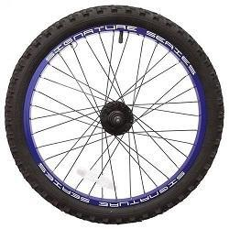

**Fig4.9:** Wheel

**4.8 FRAME**

The main function of frame is to carry whole assembly on it so it has to be strong enough to hold it. The frame is made of square pipe and it is formed out of mild steel.

**4.9 TANK**

We want our tank to carry as much fluid as it can be along with its self-weight as less as possible. We have taken a tank which is almost 16 Ltr capacity. A material for tank used is plastic fibre. Plastic fibre is very low in weight as compared to other materials. It also has very low cost.

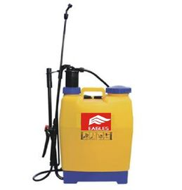

**Fig 4.10:** Tank

**4.10 BEARING**

A permanent increase in demands concerning quality bearing system leads to new developments of various technologies and new materials in order to meet high and very specific technical and economical applications. IBC Walzlager GmbH, Industrial Bearing and components, meet this fact by continuously increasing the performance of our products and technical processes, as well as ex pending our product range.

The new exad cylindrical roller bearing series stands out with extended capacity and advanced application characteristics features. Due to its optimization in design, material and production sequences it unites clear improvement concerning fatigue life, Functional safety, higher load capacity and quieter running properties with reduced friction and therefore lower heat build-up.

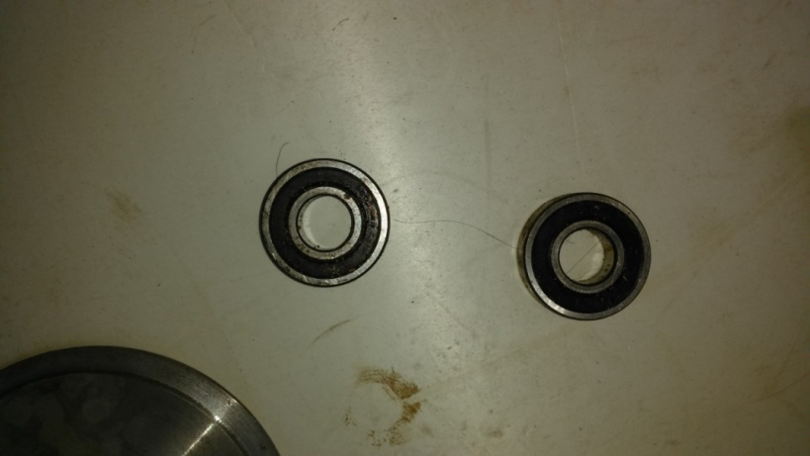

**Fig 4.11:** Bearing

Single row full complement cylindrical roller bearings of the design NJC have a self- retaining roller set. Thus the outer ring with two solid ribs and the roller assembly can be dismantled from the inner ring with a solid rib. No special safety device is necessary for preventing the rollers against falling out which makes the installation and removal substantially easier. They are also able to take on axial loads in one direction. Bearing of the design NJG are designed for slowly turning applications with especially highly loads and are manufactured in the heavy series 23.

Heat treatment single row full complement IBC cylindrical roller bearings are usually dimension stable up to an operating temperature of 120 OC. In addition and on request, higher valued heat treatment is available for higher temperatures.

The bearings for high temperatures are marked with the additional figures. Please note that the load carrying capacities of the bearings that are constantly exposed to higher operating temperatures are reduced. Radial internal clearance IBC manufactures single row full complement cylindrical roller bearing as a standard with radial internal clearance normal or C3.

Some cylindrical roller bearings are available with smaller clearance C2 or with the larger clearance C4. Bearings with clearance C% are available on request. The values of the radial internal clearance of single row full complement cylindrical roller bearings comply with DIN 620-4:1987 or ISO 5753:1991. They are valid for not built in bearings with measuring load zero. In addition, these bearings are also available with internal radial pre load as a special design.

**4.11 BASIC COMPONENTS OF SPRAYER**

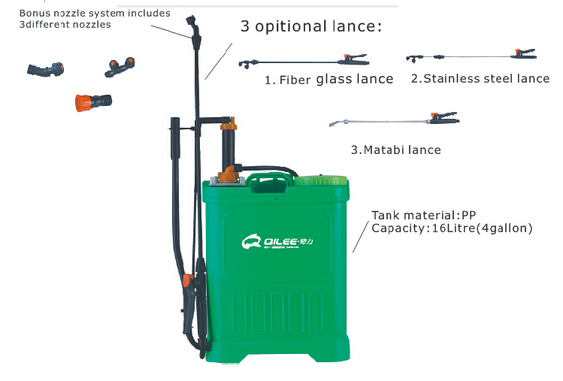

**Fig 4.12:** Components of sprayer

Parts of a sprayer pump (Fig 4.12) are as follows:

**4.11.1 Pump**

A pump is a piece of equipment used to move fluids, such as liquids or slurries, or gases from one place to another.

**4.11.2 Tank**

It is the storage place of chemical solution. It is made up of PVC, Brass, etc.

**4.11.3 Agitator**

It is the devices which stirs the solution and maintain the contents in homogenous state.

**4.11.4 Air chamber**

In a reciprocate type pump, an air chamber is provided on the release line of the pump to level out the pulsations of the pump and thus given that an invariable nozzle pressure.

**4.12 COMPONENTS OF SPRAYER PUMP**

**4.12.1 Pressure gauge**

It is a dial gauge which shows the pressure at which the liquid is delivering from the pump.

**4.12.3 Pressure regulator**

The pressure regulator use for some important functions. It is the means of adjust the pressure is necessary for any spray job within the pressure choice of the pump.

**4.12.4 Strainer**

It is a little circular plastic ring with nylon wire mesh to filter any dust element coming with the chemical solution it is included in the suction line connecting the chemical tank and the check valves.

**4.12.5 Nozzles**

It is the part which pull the fluid in to fine droplet. Mechanization of spray fluid is usually achieved by releasing the liquid through lips called nozzle under pressure.

**4.13 Types of sprayer**

Sprayers are available in variety of sizes and specifications, depending on the requirement of the plant / crop. Following are the main types of sprayers used for insecticide or pesticide sprays:

1. Low pressure sprayer

(a) Tractor mounted

  (b) High clearance sprayer

(c) Trailer-mounted Sprayers

(d) Truck mounted sprayers

2. High pressure sprayer

3. Air carrier sprayer

4. Fogger (Mist blowers)

5. Hand operated sprayer

**4.13.1 Low pressure sprayer**

These sprayers are most widely used due in part to their relatively low cost. Low-pressure sprayer types include tractor mounted, high-clearance, and trailer mounted, and truck mounted versions; they are typically operated hydraulically. Low-pressure sprayers include an air chamber to level out the pump's pulsations to provide a constant nozzle pressure, as well as pressure gages and regulators. Though booms are common on many sprayers, boom less power jet sprayers, with one to five nozzles on a single bracket, are also available.

**4.13.1a. Tractor-mounted**

In a tractor mounted configuration, a tank ranging with a capacity ranging from 150 to 500 gallons (568 to 1,893 L) is mounted on a tractor. While the pump is attached to the power take-off shaft, it may be driven by a hydraulic motor. The sprayer's booms can be located in the front, rear, or on the belly the tractor.

**4.13.1b High-clearance Sprayers**

These sprayers, derived from tractor mounted sprayers, are comprised of a tall frame that can clear corn, cotton, and tobacco, in addition to other tall crops. Additionally, high-clearance sprayers' boom height can be adjusted depending on the height of the crop.

**4.13.1c Trailer-mounted Sprayers**

Trailer mounted sprayers, mounted on a trailer and towed by an agricultural tractor, comprise a tank with a potential 1,000-gallon (3,785-L) capacity. The pump, driven by the power take-off shaft or hydraulic motor, is mounted on the sprayer. These sprayers may have a boom measuring from 12 to 50 feet (3.7 to 15 m) in length. In addition, high-clearance trailer mounted sprayers are available.

**4.13.1d Truck-mounted Sprayers**

This design consists of a skid-mounted sprayer, powered by an auxiliary engine, placed in a pickup or flatbed truck. Flotation tires are included on larger units to aid the sprayer's operation in wet conditions. These large models, including tanks that hold up to 2,500 gallons (9,463 L) and booms up to 60 feet (18.3 m) long, are most useful on expansive areas, or special applications.

**4.13.2 High pressure sprayer**

High-pressure application of chemicals is employed when spray needs to be driven through thick brush or tall trees. These sprayers, heavier and more expensive than low-pressure models, are able to operate under working pressures as high as 1,000 pounds per square inch (6,895 kPa). Aside from these differences, they are also hydraulically operated and consist of the same basic parts as low-pressure versions; they can be applied to the same tasks when outfitted with a boom.

**4.13.3 Air-carrier Sprayers**

These machines are often referred to as air-blast sprayers or mist blowers. Pesticides contained in air-carrier sprayers are transported in an air stream ranging in speed from 80 to 150 miles (129 to 241 km) per hour. Concentrated pesticides are used in these sprayers, as the air in which they are carried disperses and dilutes them considerably. The use of concentrated chemicals is therefore more efficient, as it takes little time to fill the tank when 80 percent less dilution water is required. A common type of air-carrier model is the orchard sprayer, used to spray to either one or both sides of a row of orchard trees. One type of air-carrier sprayer used in fields is mounted on a turntable to enable the spray to aim in either direction. Another type used on shade trees can spray up to 100 feet (30 m) high.

**4.13.4 Foggers (Mist blowers)**

Though these machines are used to distribute liquid pesticides, they are not actually sprayers. They are employed when an entire area such as a greenhouse or mosquito-ridden area needs to be filled with pesticides.   
Foggers are either engine-driven or electrically powered. The former models release aerosol vapour through their exhaust. Electric foggers may use a 110-120 volt current, or may receive electrical power from a car, truck, or tractor. Some larger foggers are powered with a 12-volt,horsepower electric motor; their pumps are capable of developing pressure of up to 1,800 pounds per square inch (12,410 KPa) for a powerful spray. Foggers are not suitable to be used in windy conditions.

**4.13.5 Hand operated sprayers**

  Hand operated applicators are generally used to apply small quantities of pesticides both inside structures such as greenhouses or for small jobs outdoors such as on small farms or spot treatment on larger farms.  
Hand-held sprayers usually have an air pump which compresses air into the tanks and pressurizes the spray mixture.

The pressure slowly drops as the liquid is sprayed. When the pressure gets too low, the nozzle spray pattern is poor. You must stop spraying and pump to rebuild the pressure. These sprayers operate at low pressures of 350 KPa (50 psi) or less and have small tanks of up to ten litters. Back-pack sprayers are fitted with a harness so the sprayer can be carried on the operators back. Tank capacity may be as large as 20 litters.

A hand lever is continuously operated to maintain the pressure which makes the back-pack sprayer output more uniform than that of a hand-held sprayer. Basic low cost backpack sprayers will generate only low pressures and lack features such as high-pressure pumps, pressure adjustment controls (regulator) and pressure gauges found on commercial grade units.

**CHAPTER-V**

**CONSTRUCTION AND WORKING OF MULTI SPRAY PUMP**

**5.1 Construction and Working of Push Operated Spray Pump:**

**Working Principle**

* Motion transmission by chain and sprockets arrangement.
* Slider crank mechanism.
* Rotary motion converted into reciprocating motion.

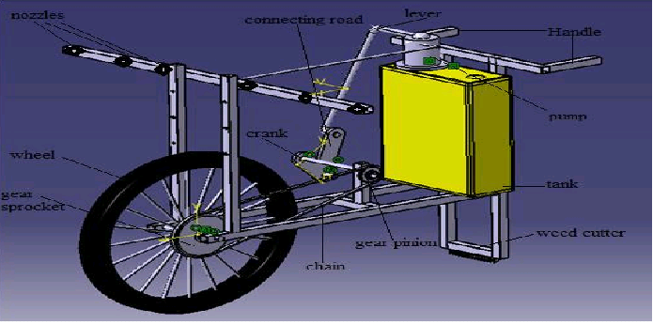

**Fig.5.1:** Agricultural reciprocating multi-sprayer

Above figure 6.1 shows the assembly of the agricultural reciprocating multi sprayer. The operator grabs the handle and pushes thecycle forward as cycle moves forward, the wheel rotate. When the wheel rotates then the gear sprocket mounted on wheel is also rotate at same speed. The chain drive transfers the motion of gear sprocket to pinion sprocket. The pinion sprocket and crank is mounted on either side of same shaft, the rotary motion of shaft is converted into the reciprocating motion with the help of crank and connecting rod mechanism. The connecting rod is also connected with lever and then the lever oscillates at fulcrum.

The piston connected at fulcrum produce reciprocating motion in cylinder and the required pressure is achieved. The pesticide from tank sucks in cylinder and piston forced the pesticide to nozzle through the pipe; the numbers of nozzles are connected to spray the pesticide. We can adjust the pressure, which is required for spraying with the help of special arrangement is to change the length of crank by providing slot on crank. By providing some adjustment at joint of connecting rod and lever free rotation of crank or neutral position can be achieved. Using these adjustments pumping is stop and the wheel rotate freely when you need not spray pesticide. Height, position and angle of the nozzle can be adjustable.

**5.1.1 Construction**

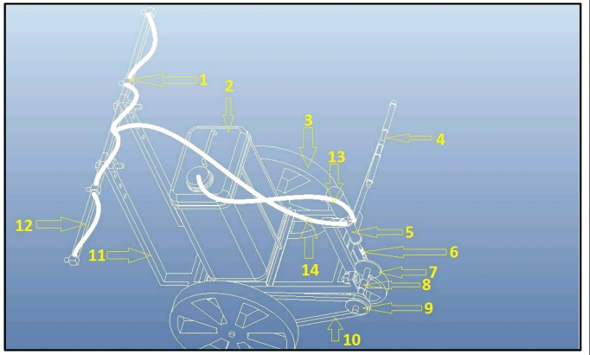

**Fig.5.2:** Construction of pump

1. Nozzle 8.Bushing

2. Pesticide Tank 9.Pulley

3. Wheel 10.V-Belt

4. Handle 11.Hight adjustment pipe

5. Cylinder 12.Nozzle support pipe

6. Connecting Rod 13.Suction pipe

7. Crank 14.Deliver pipe

**5.1.2Crank-Slotted Mechanism:**

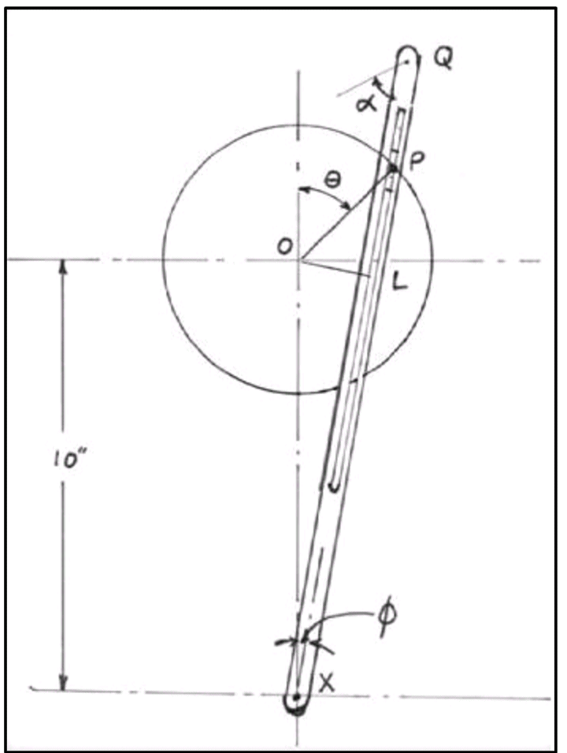

**Fig.5.3:** Crank slotted mechanism

In crank-slotted mechanism crank is connected with slotted connecting rod. One end of connecting rod is connected with crank and the other end of rod is connected with the piston rod of pump. Canter of this rod is fixed with the frame of trolley and the rod is oscillating on this point. This mechanism converts rotary motion into reciprocating motion. So this mechanism convert sprockets rotary motion into reciprocating motion of piston of pump.

**5.1.3 Working**

When we push the trolley, the wheel rotates, pulley are mounted on this wheel. So due to rotation of wheel the pulley also rotates. This pulley is connected with another pulley by the V - belt, this pulley is connected with crank slotted mechanism. This mechanism convert rotary motion into reciprocating motion.

So due to reciprocation of piston the pressure develops in the hydraulic pump. In manual operation of pump this pressure can be developed by oscillating the handle of pump. So by this mechanism we can easily develop the pressure in the pump. This pressure chamber and other end is connected with the nozzle. Thus, the pressurized pesticide-water mixture come in the discharge line and from there this mixture is came outside by the help of nozzle.

So, in simple words when we push the trolley the wheel rotates which is rotate the pulley which is connected with another pulley by the belt. This pulley rotates crank and thus the connecting rod oscillates on its fixed point and the piston of pump is reciprocate and pressure develops inside the hydraulic pump. So the pressurized pesticide come in the discharge line of pump. At the end of discharge line there are cut off valve by which we can control the pressurized pesticide and increase or decrease the flow of pressure.

The length of discharge line is adjustable so by adjusting the position of delivery pipe we can adjust the length of discharge pipe. When the distance between two rows of plant is more(Max. 0) then we can increase the length of discharge pipe, so we can easily spray the pesticide to these rows and when this distance is so closed(Min. 0) then we can decrease the length of discharge pipe and spray the pesticide easily. So in both situation we can easily spray pesticide very effectively. This is advantage of this mechanism.

**CHAPTER- VI**

**SAFETY OPERATION**

**6.1 CHAIN SELECTION**

**6.1.1 Chain failures caused by poor selection**

* Overload
* Failure of side plates due to cyclic load fatigue
* Failure of bush or roller due to impact fatigue above failures can still occur due to poor installation or maintenance
* Misalignment
* Incorrect of failed lubrication system

If correct chain is selected, installed and maintained the overall life is determined by wear

Chain failures causes and effects of chain wear

* Caused by material removal as chain components slide relative to each other
* Effect of wear is to cause chain to gradually elongate

**6.1.2 The correct chain selection**

Selecting the appropriate chain pitch Revolution ranges each chain pitch has

a) A normal revolution range;

b) A selling revolution range;

c) A maximum power transmission range.

With increasing revolution and a bigger chain pitch, the centrifugal forces generated while the chain is running on the sprocket will also increase. The increase of these forces of gravity in the range above maximum output is of a magnitude that will reduce the chain capacity.

**6.1.3 Normal revolution range:** It is recommended for technical and economical reasons to choose the chain pitch such that it will remain within the normal revolution range.

**6.1.4 Ceiling revolution range:** We recommend contacting us, if it should prove necessary to choose a chain pitch in the ceiling revolution range for reasons of the available space. This will allow us to contribute our Rexford experience towards achieving an optimal solution of the drive problems. In this revolution range, the following factors should be afforded particular attention:

1. Attenuation of oscillations and vibrations;
2. Noise abatement;
3. Chain roller fatigue strength;
4. Lubrication.

**6.1.5 General rules for choosing the chain pitch**

1. With medium tractive forces and a low chin speed, a single chain of a bigger pitch should be chosen.
2. With a high tractive force and low chain speed, a multiple chain of a bigger pitch, or even better, the relevant number of single chains adjusted in a pair and/or a group should be chosen. Fatigue strength and accordingly, operational safety, is so optimized.
3. In the existence of medium tractive forces and high chain speed, a single chain of small chain pitch would be recommended.
4. If a high tractive force at low speed is to be transmitted, them it will prove necessary to resort to a multiple chains of a small chain pitch, as is the rule with chain drives applied in oil fields.

**6.1.6 SAFETY**

Before Operating Sprayer :

1. Before attempting to use your sprayer, make sure you read the Operator’s Manual and properly understand:

* All Safety Issues.
* Assembly & Installation instructions.
* Calibration of the sprayer.
* Sprayer Operation.
* Sprayer Maintenance.

2. Read and follow instructions on chemical manufacturer’s labels.

3. Always wear applicable protective clothing.

Safety is the Operator’s Responsibility:

Your croplands spryer is designed to meet the most demanding farming conditions, where large areas. Uneven terrain and weather controlled deadlines set the toughest challenges. This machine is capable of spraying a wide range of pesticides and fungicides and the operator must be aware of the hazards associated with sprayer operation. The dealer explains the capabilities, application and restrictions of your sprayer. The dealer demonstrates the safe operation of the machine according to croplands instruction material, which is also available to operator. The dealer can also identify unsafe modifications or use of unapproved attachments.

The following publications provide information on the safe use and maintenance of the sprayer and attachments:

Operator’s Manual delivered with sprayer gives operating information, as well as routine maintenance and service procedures.

**6.2 SAFE OPERATION NEEDS A QUALIFIED OPERATOR; A QUALIFIED OPERATOR MUST DO THE FOLLOWING:**

* **Rules for Safe Use of Chemicals**
* Always read the label before using chemicals. Fallow instructions from chemical manufacturer on how to select, use and handle each chemical. Note protection information each time before opening the container.
* Always observe all warning on chemical products. Failure to do so could result in operator others being exposed to toxic chemicals which could result in serious illness. Remember chemical manufactures go to much research and expense to develop labels for your protection.
* Be sure you recognize the categories of toxicity and their key worlds.
* Verbal warnings must be given if written warnings cannot be understood by workers.
* If symptoms of illness occur during or shortly after spraying, call a physician or go to a hospital immediately.
* Follow label directions and advice to keep residues on edible portion of plants within the limits permitted by law.
* Keep bystanders away from spray drift.
* Always store chemicals in original containers and keep them tightly closed. Never keep them in anything but the original containers. Read labels for hazards about chemical reaction with certain types of metals.
* Do not still chemicals on skin or clothing. If chemicals are spilled, remove contaminated clothing immediately and wash skin (and clothing) thoroughly with soap and water. Wash hands and face with soap and water and change clothing after spraying. Wash clothing each day before reuse.
* The spray tank and system should be emptied of chemical mixture and flushed with clean water before servicing the spray system or spraying components.
* Clean the sprayer of all chemical residue before serving.
* Avoid inhaling chemicals. When directed on the label, wear protective clothing, face shield or goggles.
* Never smoke while spraying or handling chemicals.
* Cover food and water containers when spraying around live stock or pet areas.

Filter Maintenance Clean filters ensure that no solids enter the spraying system to block or damage pump or nozzles. All filters should be cleaned regularly or after each spraying period.

A complete maintenance and storage process consist of six steps: 1. Read, 2. Rinse, 3. Clean, 4. Drain, 5. Inspect, 6. Store.

**1.Read:** Before you begin cleaning your sprayer, be sure to review the label of the pesticides you have application.

* Tell you how to properly dispose of residue product.
* Provide any special cleaning instructions that might be necessary.
* Recommended decontaminating products.
* Outline the Personal Protective Equipment (PPE) you need to safely clean your sprayer.

**2.Rinse:** The goal of rinsing is to remove any concentrated or large areas of the product that might still be in or on the sprayer. Cleaning spray equipment involves circulating water through the whole system and then applying it to a site that is listed on the label of the pesticides you have used.

Several rinses sing a small volume (up to 10 percent of the spray tank capacity) is better than merely filling the spray tank once with clean water. Select a location where the rinse will not contaminated water supplies, streams, crops or other plants and where large puddles won’t accumulated, creating a hazards to humans, animals and the environment.

Preferably, the area should be impervious to water and have a wash rack or cement apron with a sump to catch contaminated wash water and pesticides. Make sure that you drain the spray tank in a manner consistent with the pesticide label. Don’t just open the valves and let it pour on the ground. Add larger volume nozzle tips for a faster and legal method to dispose of sprayer reinstate. The outside of the sprayer should also be washed.

For this purpose, applicators are encouraged to have a source of water on the sprayer in order to rinse down the sprayer in the field on the regular basis. Again, when rinsing the sprayer, do not create standing puddles that might be accessible to children, pets, livestock or wildlife.

**3. Drain:** To dispose of pesticide rinsate in accordance with label directions, apply the rinsate to a site where the products are to be used originally. In other words, the site must be listed on the label. Repeat the draining process after decontaminating and re rinsing the sprayer. Make sure that you also drain any clean water rinse tanks prior to storage to avoid damage caused by water freezing inside.

**4.Clean:** Clean after sprayer has been rinsed and drained, it’s time to clean or decontaminate it. Be sure to decontaminate both the interior and exterior of the machine, running liquid through the boom structure and out the nozzles. You don’t need to fill the sprayer. Use only enough cleaning solution to completely fill the lines and provides enough agitation. You may need to scrub or power washes the inside of the tank.

Water personal protective equipment. Cleaning agents should penetrate and dissolve pesticide residues and allow them to be removed when the rinsate is removed from the sprayer. Commercial tank cleaning agents and detergents help remove both water and oil soluble herbicides and are recommended on many pesticide labels.

Some tank cleaning agents and ammonia solutions raise the pH of the rinsate solution, making some products such as sulfonyl urea (SU) herbicides more water soluble and thus easier to remove from internal sprayer parts.

Chlorine bleach solutions hasten the breakdown of SU’s and some other herbicides into inactive compounds. However, chlorine is less effective at dissolving and removing SU herbicides residues from spray tanks than ammonia solution. Never add chlorine bleach to ammonia or liquid fertilizers containing ammonia, because the two materials react to form toxic chlorine gas.

**5. Fuel oil or kerosene**:Fuel oil or kerosene is effective for removing oil-soluble herbicides such as esters and emulsifiable concentrates. The fuel oil or kerosene should be followed by a detergent rinse to remove the oily residue. Also run cleaning solution throughout the sprayer, including the agitation system and the return lines. Then rinse the system with clean water. Open all nozzles until they are spraying pure water. .Inspectafter the final rinse you can inspect your sprayer and make the necessary repairs and modifications. Even though the sprayer has been “cleaned”, always wear personal protective equipment. Some residue may remain on and in the sprayer. Here is a checklist of what to look for both during and after cleaning:

* Mismatched and worn nozzles
* Damaged nozzle screens
* Damaged strainer screens
* Cracks, leaks and overall performance in the pump.
* Hose condition, especially brittleness or cracks.
* Valve condition, identifying any possible leaks or areas where seals may have loosened.
* Boom structure identifying any cracks that must be fixed Modification some handy modifications might be.
* Shut- off valves on either side of the pump to facilitate pump removal and repair.
* Shut –off valves at the boom
* Shut-off valves at the tank
* Additional pressures gauges
* Installing tank level indicators
* By pass and agitators lines
* Engine kill switches.
* Additional lines to aid in cleaning i.e. broad jets for spraying out rinsate as opposed to using boom

**6.Store:** Store now that the sprayer has been thoroughly cleaned, you many want to remove parts of it that may be damaged during storage.

* Remove strainers (filters) and wash them by hand with soapy water (remember to wear chemical resistant gloves), rinse them and either store them or place them back in the sprayer.
* Pay special attention to nozzles, nozzle bodies and check valve. Chemical residue can build up in these areas and harden over winter, dramatically reducing the sprayer’s performance next season.
* Remove nozzle tips, screen, check valves, caps and nozzle bodies from the nozzle body assemblies. Correctly plug the assemblies.
* Clean and rinse out the nozzle tips, nozzle bodies and check valves. Store in a marked container. Store check valves at room temperature over the winter to avoid damage that can be caused by freezing temperatures.
* Remove all pressure gauges and cap the opening on the sprayer.

**CHAPTER - VII**

**COST ESTIMATION**

**7.1 COST ESTIMATION OF THE PROJECT**

The following Cost Estimation of the Project is tabulated in Table 6.1.

|  |  |  |
| --- | --- | --- |
| **Sr. No.** | **Materials** | **Cost (Rs.)** |
| 1. | Pipe (27 Classic) | 450/- |
| 2. | Pipe Bending | 150/- |
| 3. | Chain | 800/- |
| 4. | Sprocket | 600/- |
| 5. | Small Sprocket | 250/- |
| 6. | Rim | 500/- |
| 7. | Threading Sprocket | 360/- |
| 8. | Tank | 1700/- |
| 9. | Pipe | 170/- |
| 10. | Bearing | 120/- |
| 11. | Nozzles | 120/- |
| 12 | Cap Storage tank | 140/- |
| 13. | Tee | 200/- |
| 14. | Steel pipe | 60/- |
| 15. | Turning shaft | 490/- |
| 16. | Shaft | 600/- |
| 17. | Scrap hardware | 600/- |
| 18. | Welding | 700/- |
|  | **Total** | 8010/- |

**Table 7.1:** Cost estimation

**CHAPTER - VIII**

**ADVANTAGES AND DISADVANTAGES OF MULTI SPRAYER**

**ADVANTAGES**

1. Agricultural sprayers are commonly used to apply liquid fertilized, pesticides or other liquids to crops during their growth cycle.

2. It is Simple in construction.

3. Comparatively hand operated sprayer, easy to handle without any pain.

4. Unskilled operator should very easily handle and operate.

5. It Comparatively less cost in construction in design.

6. Compared to electric and hand pump uniform and desired flow pressure through the nozzle.

7. Height of the nozzle system should be adjustable in sprayer system.

8. Weight of the system should be less as comparative others.

9. This Sprayer system should be easy to connect with bike as well as tractors.

**DISADVANTAGES**   
 1.The initial cost is high to some extent as compared to conventional sprayer.

**APPLICATIONS**

1. For the insecticides application to control insect pests on crops and in stores, houses, kitchen, poultry farms, etc.

2. For the fungicides and bactericides application, to control the plant diseases.

3. For the harm any sprays application to increases the fruit set or to prevent the premature dropping of fruits.

4. For the application of plant nutrients as foliar spray.

5. For applying the powdery formulation of poisonous chemicals on the crops and for any other purposes.

6. Pesticides sprinkling.

**CHAPTER-IX**

**DESIGN OF MULTI NOZZLE WHEEL SPRAY**

**9.1 DESIGN OF WHEEL**

Distance between two plants = 1.25 feet

= 38 cm.

Line covered by one rotation of wheel = 4

38 * 4 = 152 cm

152 = 2πr

r = 152/2π

r = 25 cm

The diameter of wheel = 50 cm

**9.2 DESIGN OF PINION**

Minimum no. of teeth available on pinion = 18

Outer dia. Of pinion = 8 cm

= 80 mm

Inner dia. Of pinion = 6.5 cm

= 65 mm

Pitch circle dia( Dp ) = (DO-DI) / 2 +(DI)

= (80-65) / 2 + 65

Dp = 72.5 mm

Gear Ratio = 1:3

On rotation of gear sprocket gives three rotation of pinion sprocket, we required three strokes to generate adequate amount of pressure**.**

**9.3 DESIGN OF GEAR SPROCKET**

1/3 = tp / tg

1/3 = 18/tg

tg = 18 * 3

tg = 54

Tp /tg = Dg / Dp

3/1 = Dg / 72.5

Dg = 218 mm.

**9.4 DESIGN OF CHAIN**

Chain type roller chain.

ISO Chain no. 05B

Pitch = 0.25 mm

Length of chain , L = K.P

No. of chain ,

K = (T1  + T2 ) / 2 + (2 X ) /P + (T2-T1) / 2π * ( P/X)

K = (18+54) / 2 + (2*478) / 0.25 + (54-18) / 2π * (0.25/478)

K = 36 + 3824 + 0.00299

K = 3860 mm

L = K * P L

= 3860 * 0.25

L = 965 mm

L = 96.50 cm

**9.5 DESIGN OF CRANK AND CONNECTING ROD BY USING SYNTHESIS OF MECHANISM (THREE POSITION METHOD)**

Crank = 5.1 cm

Connecting Rod = 10.8 cm

**9.6 NOZZLE SELECTION**

Diameter of wheel = 50 cm

Let’s consider farm of 1 Acre,

Therefore, 1 Acre = 4046.86 m2

Number of plants in 64 meters = 64/0.78 = 168

From survey earlier when hand backpack spray pump used then 60 ltr. of pesticide are used for 1 Acre farm.

Consider 60 ltr. of pesticide is required for 1 Acre farm so how much amount of pesticide is required for one plant .

Total number of plants in 1 Acre, 168 * 168 = 28224

60 ltr. For 1 Acre, 60/28224 =2.1258 * 10-3 ltr / Plant.

Consider time required for 1 acre farm to spray a pesticide is 3 hrs. = 180 minute

=180 / 28224

=6.3775 * 10-3 min / Plant

=1/ 6.3775 -3

= 156.8 Plant/min.

Discharge = (2.1258 * 10-3) * (156.8)

Discharge = 0.3333 Ltr /min.

Find the pressure drop,

P2 = 1.279 bar

Pressure drop = 0.72 bar

**9.7 DESIGN OF MANIFOLD AND PIPE SELECTION**

When we carry out small survey we come to know that various pump are use by different farmers but the most probably use pump is having capacity 16 Ltr. with pressure of 2-4 bars. Pump Pressure = 2 - 4 bars

Spray Pipe Material = Plastic

Pump discharge = 2 ltr. /min

= 3.333 10-5 m3/sec.

Q = A * V

V =8.88 * 10-8 / (π/4) d2

=4.244 * 10-8 /d2 m/sec.

Major Losses,

Take a Friction Factor, f = 0.09

hfm = (4fLV2) / (2gd)

= (0.5) * ((4.244 * 10-8/d2)2) / (2) * (9.81)

=1.128 * 10-10/d5

Loss at Entry,

hfE = (0.5V2) / (2g)

= (0.5) * ((4.244 * 10-5/d2)2) / (2) * (9.91)

= 4.590 * 10-11/d4

Loss at Out,

hfO = (KV2) / (2g) = (0.54) * ((4.244 * 10-5/d2)2) / (2) *( 9.91)

= 9.190x10-11/d4

Loss at T Section

Take, Bending Coefficient, k = 0.54 for 90°

hft = (KV2)/2g

= (0.54) * ((4.244 * 10-5/d2)2) / (2) * (9.91)

= 4.9578 * 10-11/d4

Total Losses, hfT = hfm + hfE + hfO + hft

hfT = (1.123 * 10-10/d5) ± (4.590 * 10-11/d4) ± (9.180 * 10-11/d4) ± (4.9578 *10-11/d4)

Required Pressure at nozzle is 2 bar,

Therefore, pressure, P = 2 bar

= 2 * 105 N/m2

P = ρ *g *h

(2*105)= (1000) * (9.81) * (h)

h = 20.38 m of water

Therefore,

hfT = 1.128*10-10/d5) ± (4.590 *10-11/d4) ± (9.180*10-11/d4) ± (4.9578*10-11/d4)

20.38 = 1.128*10-10/d5) ± (4.590*10-11/d4) ± (9.180*10-11/d4) ± (4.9578*10-11/d4)

d = 5.611 * 10-3 m

d = 5.61 mm

= 0.6 cm

**9.8 DESIGN OF PUMP**

We are going to join six nozzles then pump required to produce the discharge is,

(6 * 0.3333) = 2 Lpm

Total discharge of pump is 2 lpm. For above discharge, which pump give pressure above 2 bar is to be selected.

**9.9 DESIGN OF FRAME**

Lengh of frame = Center distance between two sprockets + width of

Tank + Excess

= 478 + 130 + 242

L = 850 mm

Height of Frame = 776 mm

Width of Frame = 500 mm

Total length of pipe = (850 * 2) + 200 + (600 * 2) + 1000 + (775 * 2) + 100

= 5750 mm

Cross section area of square pipe = 25.2 * 2 = 51 * 4 sides = 204 mm2

Volume of frame = 204 * 5750 = 1173000 mm3

Density of M.S.material = 7.7 * 10-6 kg / mm3

Density = mass / volume

Mass = density * volume

= (7.7 X 10-6) * (1173000)

Mass = 9.03 kg

Total weight of assembly = 15+2+1+9 = 27 kg * 9.81m/s2

= 264.87 N

Yield stress of material = 247 N/mm2

Area = 5750 * 25.4

= 146050 mm2

Stress = Load / area

= 264.87 / 146050

= 0.0181 N/mm2

Therefore, 0.0181 < 247 N/mm2, hence the design is safe.

**CHAPTER- X**

**TESTING & PERFORMANCE OF MULTI SPRAYER**

**10.1 TESTINGS**

Testing on crop like Brinjal, Fenugreek and Tobacco, which crop having their height, should be minimum 4ft. Firstly we get 6000 sq. ft farm land and selecting the crop. We use our project for spraying the pesticide. At a time we select both sprayer mechanism hand pump and bicycle sprayer. Then sprays the pesticide by hand operated pump on Brinjal farm, time spend for that 1 hour for complete 6000 sq. ft. After that Bicycle sprayer is used for that 6000 sq. ft. of Brinjal land and start the pesticide spraying it get 25 min for spraying that land area. Hand pump when operating there is cranking comes in hand and because of that there is no continuous flow produce and it is not possible to handle that weight of that tank continuously on the back and because of back ache pain start.

Bicycle sprayer is used for spraying, it is easy to handle and it having stand to hold at a 1.5 ft and when starting spraying that time easy to hold the mechanism. At a time 3 rows covers the spray for spraying system. Both directions in V shape spray pesticide on crop. Pump creates same pressure in both mechanism but in Bicycle sprayer this pressure equally distribute in 4 nozzles. And comparatively 2.5 times efficiency is greater than hand pump operated pump. Here continuous flow is possible because a person who walks at 6 km/hr speed and easy to walks in the farm row. And revolution of the wheel completes in 1.48 sec and piston movement 3 times in one revolution of wheel. A person is hold bicycle sprayer in back side and walk forward side.

In the performance of both equipment’s are used for pesticide spraying in the same farm land and same area. When both mechanism test getting, Bicycle sprayer works easy than Hand pump spraying mechanismand it works efficiently 2.5 times of Hand pump mechanism. Hand Pump takes 1 hour time for spray pesticide in the 6000sq. ft. and Bicycle sprayer mechanism takes same area and spends 25 min. It reduce the time comparatively Hand operated pump.

When Hand operated pump takes on the back of the body its weight is high and continuously hand pumping is not possible. Transportation of full tank of pesticide with water is produces the pain in body or hand. At a time sprayer sprayed one side of the crop and it gets lengthy process.

Bicycle mechanism is takes low load, because load of the tank distribute on the all frame in equally. When sprays the pesticide on the crop at different height is possible and at a time it takes 3 row and crop five sides covers and takes less time it get result. Pesticides equally distributed by the nozzle and continue flow is possible.

**10.2 OBSERVATIONS**

|  |  |  |  |
| --- | --- | --- | --- |
| **S. No.** | **Types of crops** | **Area** | **Time** |
|  | Brinjal | 6000 sq. ft | 60 min |
|  | Tobacco | 7000 sq. ft | 80 min |
|  | Fenugreek(Methi) | 5000 sq. ft | 50 min |
|  | Tomato | 5000 sq. ft | 50 min |
|  | Wheat | 6000 sq. ft | 60 min |
|  | Sugar cane | 20000 sq. ft | 120 min |

**Fig 10.1:** Hand operated pump

|  |  |  |  |
| --- | --- | --- | --- |
| **S. No.** | **Types of crops** | **Area** | **Time** |
|  | Brinjal | 6000 sq. ft | 25 min |
|  | Tobacco | 7000 sq. ft | 30 min |
|  | Fenugreek(Methi) | 5000 sq. ft | 20 min |
|  | Tomato | 5000 sq. ft | 25 min |
|  | Wheat | 6000 sq. ft | 25 min |
|  | Sugar cane | 20000 sq. ft | 50 min |

**Fig 10.2 :** Mechanism Bicycle Sprayer

**10.3 RESULTS**

Spraying by both methods and we find the result from observation is hand pump gets spraying pesticide 1 hour takes time for 6000 sq. ft. farm land and it’s more consume time and not continuously pressure creates. It is not continuously hanging on back side. When we use Hand pump it spread the pesticide on the one side of crop and when we used our Bicycle sprayer mechanism, it is comfortably handled by farmer. It takes less time and covers large area of crop. It covers the three rows of farm land. And when use our mechanism in the same Brinjal farm then it covers in 25 min. It covers 2.5 times of hand pump spraying in time.

**CHAPTER-XI**

**CONCLUSION**

It is upgraded design of manually operated sprayer and weeder which will be helpful for small land farmers. It consumes less time and saves money as compared with conventional spraying and weeding. This machine does not require any fuel or power so maintenance is less. This model removes problem of back pain, vibrations and noise. This alone pump can used for multiple crops. The model has provided multiple nozzles, which has continuous spray over crop and this process takes less time than other sprayers for spaying.

**REFERENCES**

[1] Prof. Sumit D. Raut, Prof. Kamlesh R. Banarse, Prof. Roshan R. More, “Fabrication of pedal operated pesticide sprayer for agricultural and drainage line use”, IJPRET, Volume 2(9): 67-74, ISSN 2319-507X, Issue 01, June 2014

[2] Shivaraja kumar . A, Parameswara murthy. D, “Design and development of wheel and pedal operated sprayer”, IPASJ International Journal of Mechanical Engineering (IIJME), ISSN 2321-6441, Volume 2, Issue 06, June 2014

[3] S R Kulkarni, R V Nyamagoud, Harish Naik, and Mohan Futane, “Fabrication of Portable Foot Operated Agricultural Fertilizers and Pesticides Spraying Pump”, International Journal of Engineering Research & Technology (IJERT), ISSN: 2278-0181, Vol. 4 Issue 07, July-2015 Theses :

[4] David McAuliffe and Vanessa P. Gray, Application Technology: “Problems and Opportunities with Knapsack Sprayers, Including the CF Valve™ or Constant Flow Valve”.

[5] Application technology: Problems and opportunities with Knapsack sprayer, Including the of valves or Constant Flow Valves.- David McAuliffe and Vanessa P. Gray.

[6] Journal of arboriculture weed control in landscape plantings1 by J.F. ahrens April 1981 vol. 7, no. 4.

[7] Backpack Sprayer-Modified for small farm Crop Protection-Rutgers Snyder Research & Extension Farm Staff–Edited by John Grande and Jack Rabin.

[8] To Spray or Not to Spray: Pesticides, Banana Exports, and Food Safety John S. Wilsona Tsunehiro Otsuki*,b a b Development Research Group (DECRG), World Bank, 1818 H Street NW, Washington, D.C. 20433, USA March 2002. [9] Farmers understanding of pesticides safety labels and field spraying practices. By Oluyede Clifford Ajayi and Festus K. Akinnifesi Scientific Research and Essay Vol (2), pp.204-210, June 2007 ISSN 1992-2248@2007 Academic Journals.